***Smart SDLC AI enhanced software***

***Development LifeCycle.***

**Team Members**

**▪ Abirami.V**

**▪ Pavithra.T**

**▪ Gobika.G**

**▪Sathya Priya.M**

**1. INTRODUCTION**

**The Smart SDLC – AI Enhanced Software Development Lifecycle is an advanced framework**

**that integrates Artificial Intelligence (AI) into each phase of the traditional software**

development process. This model builds upon existing methodologies like Waterfall, Agile**,**

**and DevOps by embedding AI-driven tools to automate tasks, optimize workflows, and**

**enhance accuracy.**

**2. PROJECT OVERVIEW**

**The Smart SDLC is designed to revolutionize software development by providing intelligent**

**assistance at every stage. It introduces AI-driven features such as conversation interfaces,**

**policy summarization, resource forecasting, eco-friendly development tips, anomaly**

**detection, KPI forecasting, multimodal input, and AI-powered dashboards.**

**Key Features:**

**• Conversational Interface – Enables natural communication between AI, developers, and**

**clients.**

**• Policy Summarization – Ensures responsible AI usage and compliance.**

**• Resources Forecasting – Predicts time, cost, and resource allocation.**

**• Eco-Tip Generator – Suggests energy-efficient and sustainable development practices.**

**• Citizen Feedback Loop – Integrates continuous feedback from end-users.**

**• KPI Forecasting – Tracks and predicts project success metrics.**

**• Anomaly Detection – Detects irregularities and risks in the development process.**

**• Multimodal Input Support – Accepts text, voice, image, and sketch inputs.**

**• Streamlit to Gradio UI – Interactive, user-friendly, and AI-powered dashboards.**

**3. ARCHITECTURE**

**The architecture of Smart SDLC consists of two major components:**

**Front-end: AI-powered multimodal interface with dashboards, chatbots, and feedback**

**forms.**

**Back-end: Cloud-based infrastructure integrated with AI/ML models, databases, and APIs.**

**Key Components:**

**• LLM Integration – Connects AI models to automate tasks like requirement analysis, coding,**

**and testing.**

**• Vector Store – Retains project knowledge in embeddings for quick recall and reference.**

**• ML Modules – Specialized AI models for requirements, testing, forecasting, and anomaly**

**detection.**

**4. SETUP INSTRUCTION**

**Prerequisites:**

**• Python 3.8+ installation**

**• Streamlit / Gradio for UI**

**• TensorFlow / PyTorch for ML models**

**• LangChain / Transformers for LLM integration**

**• Vector database (FAISS, Pinecone, Weaviate)**

**Installation Steps:**

**1. Install Python 3.8+**

**2. Install dependencies using 'pip install -r requirements.txt'**

**3. Configure vector database and API keys**

**4. Run backend server and frontend UI**

**5. AUTHENTICATION**

**Smart SDLC employs secure authentication mechanisms to prevent unauthorized access,**

**safeguard sensitive project data, and ensure role-specific access. Security tokens and**

**encrypted logins help build trust among stakeholders.**

**6. USER INTERFACE**

**The Smart SDLC user interface is designed to be intuitive and interactive. Dashboards**

**provide real-time project tracking, while AI-powered chatbots allow seamless**

**communication. The UI ensures collaboration, accessibility, and efficiency.**

**7. TESTING**

**Testing in Smart SDLC is AI-driven, automating the generation of test cases, monitoring**

**system performance, and detecting defects. This results in higher quality assurance and**

**faster debugging cycles.**

**8. KNOWN ISSUES**

**• Occasional delays in LLM response for large queries**

**• AI-generated code may require manual adjustments**

**• Multimodal input (voice, image) may face inconsistencies**

**• Vector store retrieval failures in rare cases**

**• System performance dependent on internet/cloud stability**

**9. FUTURE ENHANCEMENTS**

**• Advanced LLMs for faster and more accurate results**

**• Real-time multi-user collaboration**

**• Enhanced multimodal input (voice, sketch, video)**

**• Predictive analytics for risk and cost estimation**

**• Automated deployment pipelines**

**• Improved security and scalability**

**10.Project Screenshot**

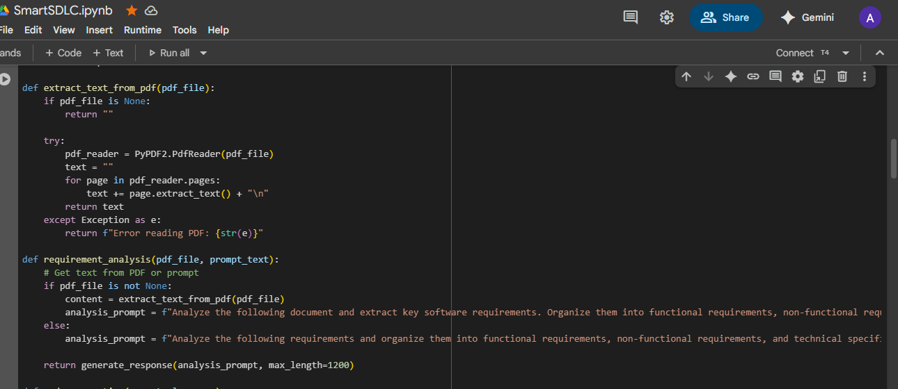

***THANK YOU!***